
Associate Professor Alison Blatt
BMed (Hons) MS FRACS FUSANZ

Bladder Diary with Catheter Residuals

Bladder Diary 24 hour instructions
- Start making notes when you wake up and wee on the first day.
- Make a separate entry for every drink and every void.
- Record input (drinks) and output (wees) in mls.
- If you use a catheter straight after a wee, record these volumes the next column after you have attempted a wee (see example below).
- Use ‘events’ for any extra information eg leakage,pad change,pain,urge etc
- Continue recording overnight, up to and including the first void on day 2

Example

Time | Drink | Wee | Catheter | Comments
6.30am | _______________ | 350mls | 150mls | Leak on the way +
7.00am | Coffee 250mls | ____________ | __________ | ____________
10.00am | _______________ | 100ml | __________ | Large Pad wet +++
11.00am | Tea 250ml | ____________ | __________ | ____________
11.30am | _______________ | ____________ | 380ml | Unable to wee
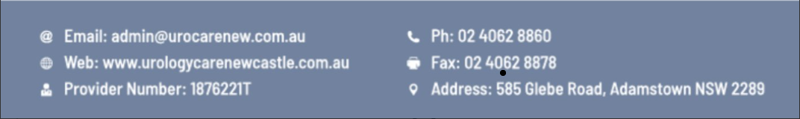

Name:

Date:

Time | Drink | Wee | Catheter | Comments/Pain/Leak/Pads

