
Associate Professor Alison Blatt
BMed (Hons) MS FRACS FUSANZ

Bladder Diary

Bladder Diary 24 hour instructions
- Start making notes when you wake up and wee on the first day.
- Make a separate entry for every drink and every void.
- Record input (drinks) and output (wees) in mls.
- Use ‘events’ for any extra information eg leakage,pad change,pain,urge etc
- Continue recording overnight, up to and including the first void on day 2

Example

Time | Drink | Wee | Comments
6.30am | _______________ | 350mls | Leak on the way +
6.55am | _______________ | ____________ | ____________
7.00am | Coffee 250mls | ____________ | ____________
10.00am | _______________ | 100ml | Large Pad wet +++
11.00am | Tea 250ml | ____________ | ____________
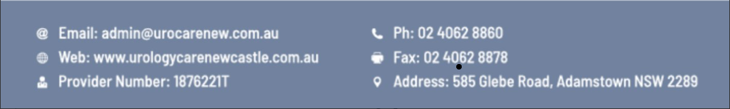

Name:

Date:

Time | Drink | Wee | Comments/Pain/Leak/Pads

